**Tutorial problems**

**T7.** A tension test is carried out subjected on a mild steel tube of external diameter 18 mm and internal diameter 12 mm. An an axial load of 2 kN produces an extension of 3.36 x 10-3 mm on a length of 50 mm and a lateral contraction of 3.62 x 10-4 mm of outer diameter.

Determine E, μ,G and K.

**T8.** The modulus of rigidity of a material is 0.8 x 105 N/mm2 . When a 6 mm x 6 mm bar of this material is subjected to an axial pull of 3600 N, it was found that the lateral dimension of bar is changed to 5.9991 mm x 5.9991 mm.

Find μ and E.

**T9.** A hole is to be punched out of a plate having an ultimate shear stress of 300 MPa. If the compressive stress in the punch is limited to 400 MPa,

determine:

(a) Maximum thickness of the plate for which a 100 mm dia hole can be punched.

(b) If the plate is 10mm thick, smallest diameter hole that can be punched.

**T10.** A bar of steel 40 mm x 40 mm cross section and 150 mm long is subjected to a tensile load of 200 kN along its longitudinal axis and tensile load of 600 kN and 400 kN along lateral axis.

Find,

(a) Change in each dimension and change in volume

(b) What longitudinal force alone can produce same longitudinal strain as in case (a).

Given E= 200 GPa μ=0.3

**T11.** Determine the magnitude of the load P necessary to produce zero net change in the length of the bar shown in the figure below. Take A=400 mm2.

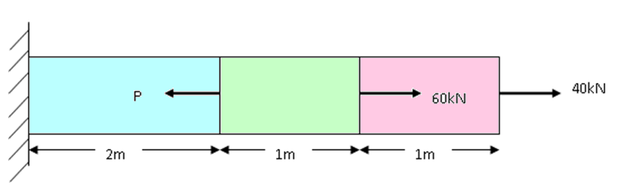

**T12.** For the bar shown below, determine diameter of the central portion and its length, if the total extension of the bar is 0.16 mm. Take E=200 GPa. Stress at central portion is limited to 140 N/mm2

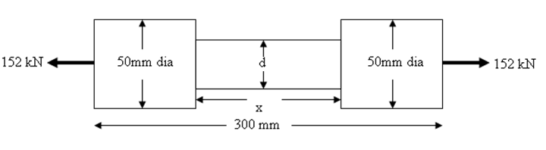

**T13.** A piece of 180mm long by 30mm square is in tension under a load of 50kN as shown in the figure. If the modulus of elasticity of the material is 120GPa and Poisson’s ratio is 0.25, find the change in the length if all lateral strain is prevented by the application of uniform lateral external pressure of suitable intensity

